ICP - 6

**Ghit hub link:**<https://github.com/poojasrinivas29/icp_5/upload>

**Video link:**https://drive.google.com/file/d/1JVIkm7HHGPhOECQr_63xVAx6-lH8rvs3/view?usp=sharing

1. Follow the instruction below and then report how the performance changed.(apply all at once) • Convolutional input layer, 32 feature maps with a size of 3×3 and a rectifier activation function. • Dropout layer at 20%. • Convolutional layer, 32 feature maps with a size of 3×3 and a rectifier activation function. • Max Pool layer with size 2×2. • Convolutional layer, 64 feature maps with a size of 3×3 and a rectifier activation function. • Dropout layer at 20%. • Convolutional layer, 64 feature maps with a size of 3×3 and a rectifier activation function. • Max Pool layer with size 2×2. • Convolutional layer, 128 feature maps with a size of 3×3 and a rectifier activation function. • Dropout layer at 20%. • Convolutional layer,128 feature maps with a size of 3×3 and a rectifier activation function. • Max Pool layer with size 2×2. • Flatten layer. • Dropout layer at 20%. • Fully connected layer with 1024 units and a rectifier activation function. • Dropout layer at 20%. • Fully connected layer with 512 units and a rectifier activation function. • Dropout layer at 20%. • Fully connected output layer with 10 units and a Softmax activation function Did the performance change?

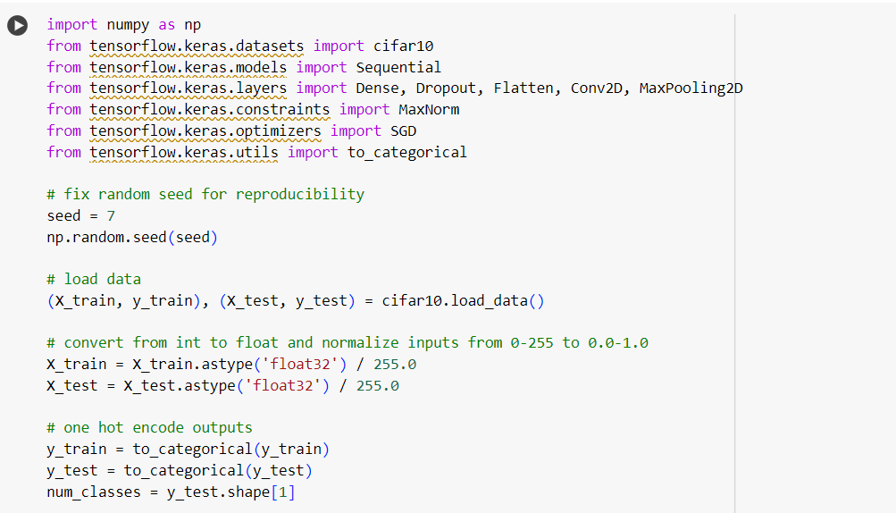

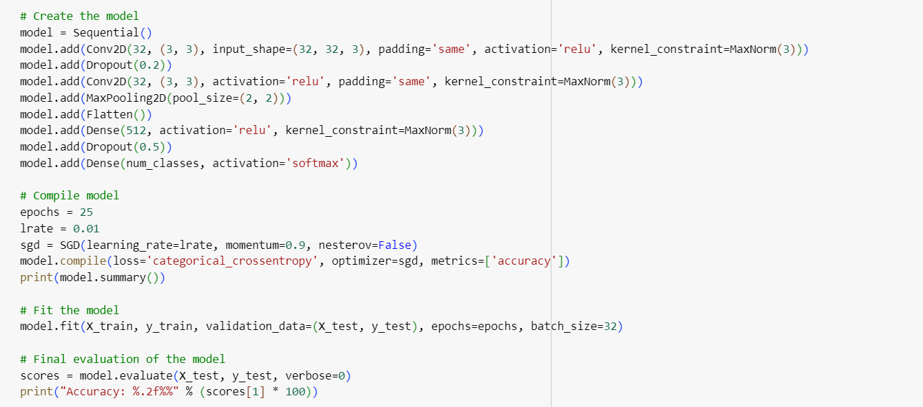

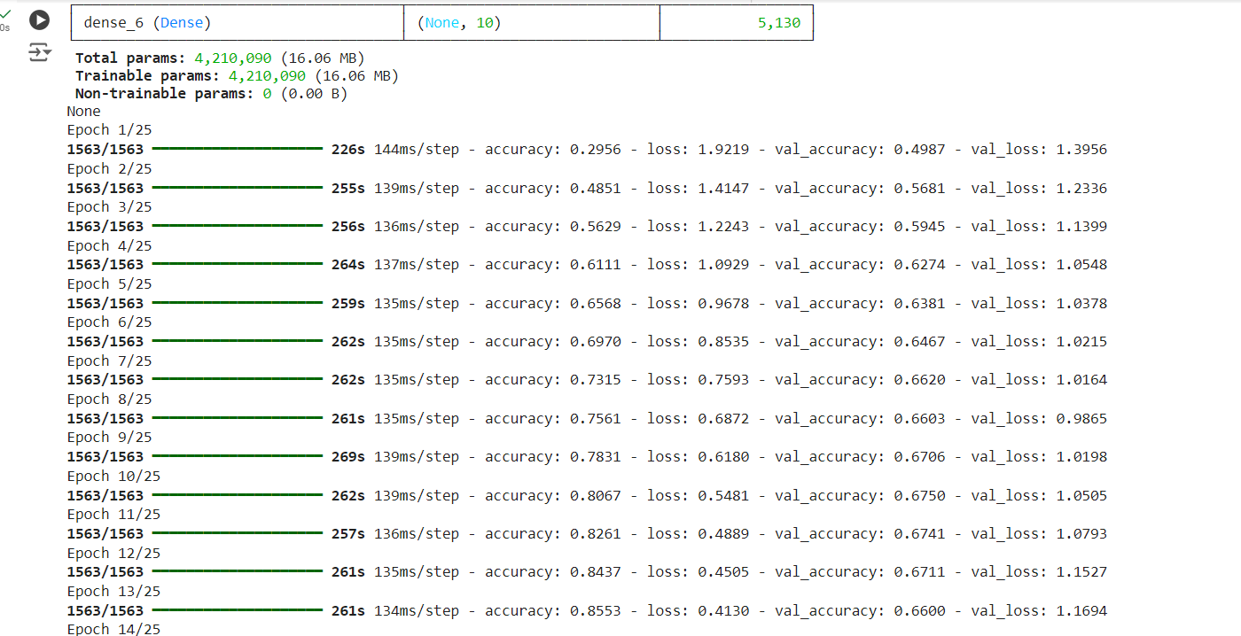

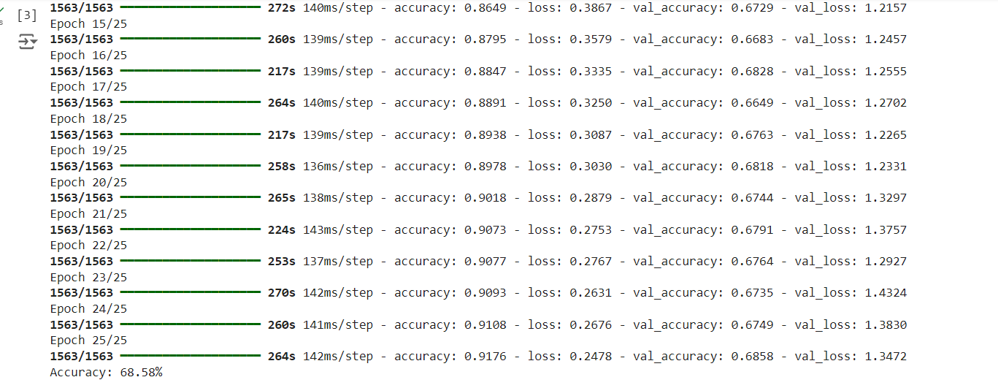

2. Predict the first 4 images of the test data using the above model. Then, compare with the actual label for those 4 images to check whether or not the model has predicted correctly

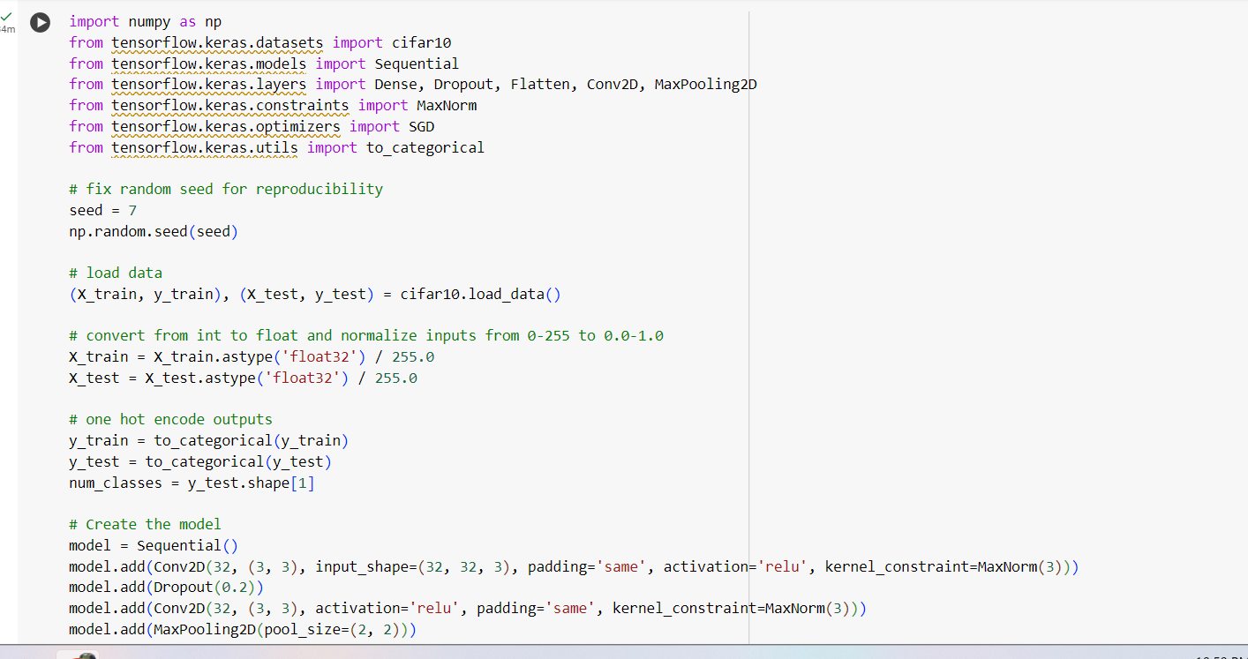

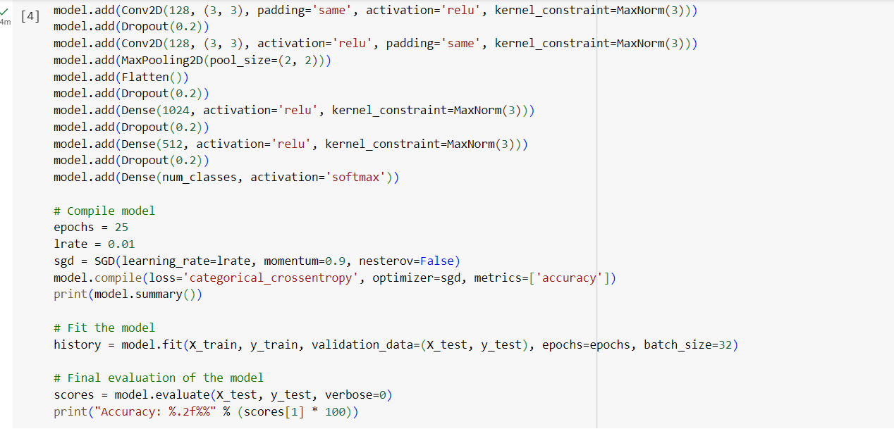

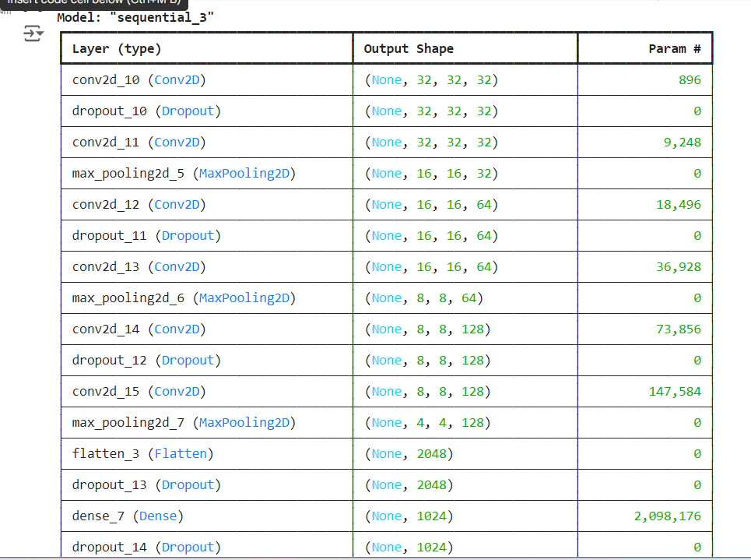

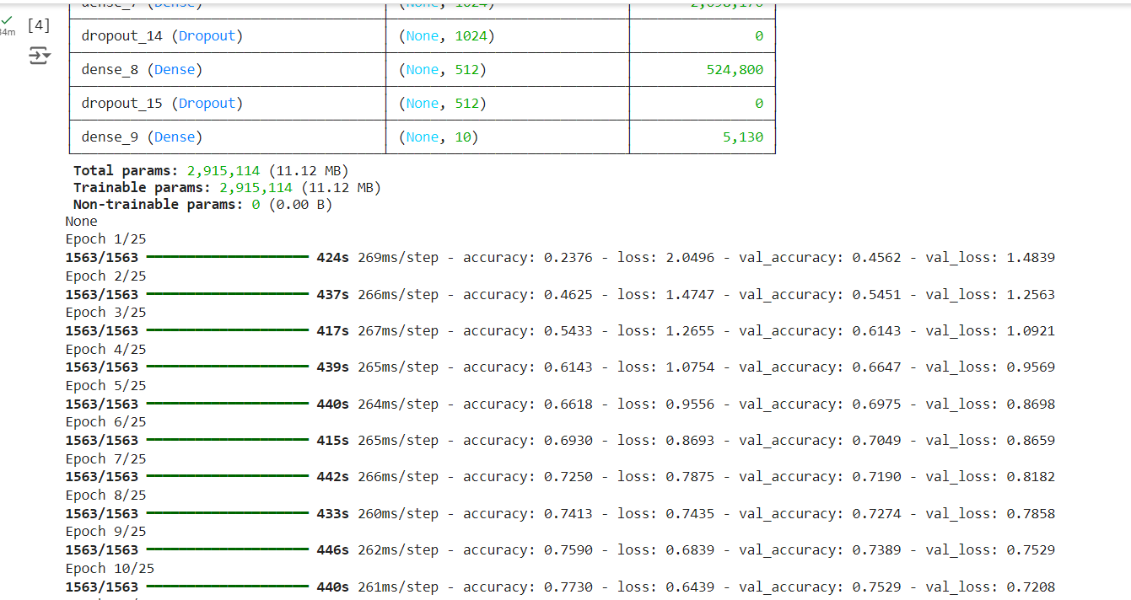

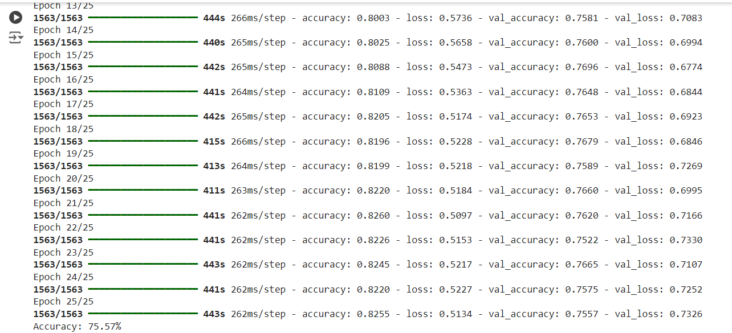

3. Visualize Loss and Accuracy using the history object.

